**FULL STACK**

**ASSIGNMENT- 1 & 2**

**BY**

**Mohamed Aslam K**

**21BAD051**

**1)**

**10 days of JavaScript**

**2)**

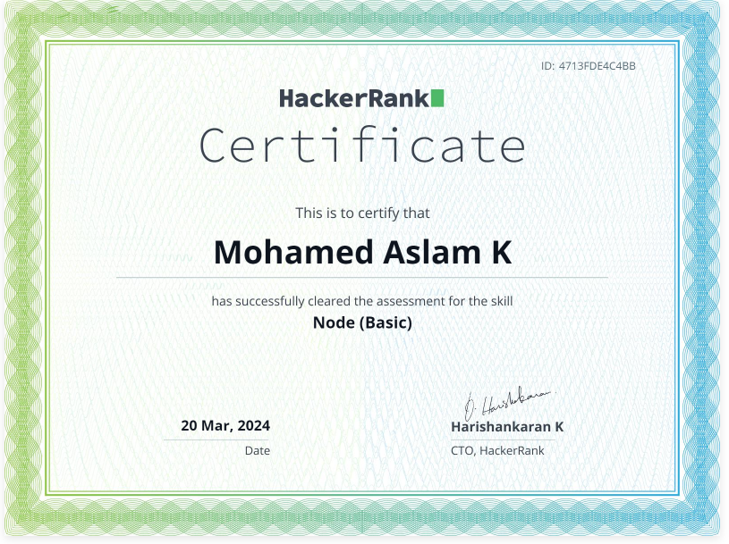

**Node Basics**

**3)**

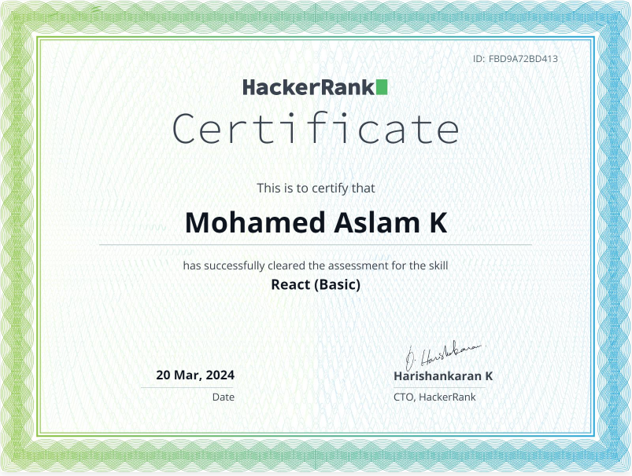

**React Basic**